
Revision Exercise 1 - Count, order, compare & represent whole numbers, Number sentences, Rounding off to the nearest 10 & 100

1) Write down the missing numbers:
a) 40, ____, 60, ____, 80, ____ b) 350, ____, 450, ____, ____, 600
2) Write this number down in figure (number form): Three hundred and fourteen
___________________________________________________________________
3) Write this number down in words: 425
___________________________________________________________________
4) Write this number down in ascending order: 102, 34, 721, 43, 901
___________________________________________________________________
5) Look at the following number: 855
a) Is this number odd or even
________________________________________________________________
b) Write down the place value and value of the underlined digit
________________________________________________________________
6) Write these numbers in expanded notation
a) 403: ___________________________________________________________
b) 627: ___________________________________________________________
7) Complete these number sentences:
a) 20 - = 13 ________________________
b) 40 + = 100 ________________________

8) Say whether the following is true or false:
a) 27 + 12 = 12 + 27 ______________________
b) 27 – 12 = 12 – 27 ______________________
9) Complete these subtraction number sentences, then use addition to check each one
a) 65 – 23 = Check: ____ + ____ = ____
b) 100 – 36 = Check: ____ + ____ = ____
10) Complete these pair of number sentences. Add the numbers in the brackets first.
Show all your working
a) (18 +17) + 4 = (17 + 4) + 18 =
_______________________ _____________________
_______________________ _____________________
b) (45 + 35) + 15 = (35 + 15) + 45 =
______________________ _____________________
______________________ _____________________
11) Round 205 to the nearest 10: ________________________________
12) Round 426 to the nearest 100: _______________________________
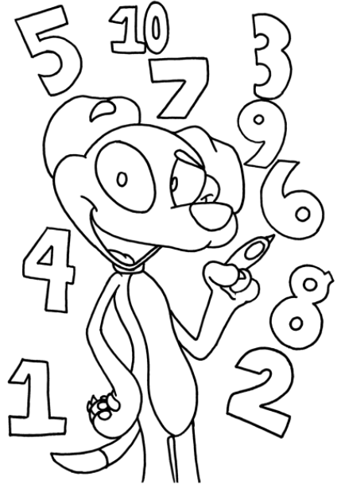

Answer Sheet – Revision Activity 1

1) Write down the missing numbers:
a) 40, 50, 60, 70, 80, 90 b) 350, 400, 450, 500, 550, 600
2) Write this number down in figure (number form): Three hundred and fourteen
314
3) Write this number down in words: 425
Four hundred and twenty-five
4) Write this number down in ascending order: 102, 34, 721, 43, 901
34, 43, 102, 721, 901
5) Look at the following number: 855
a) Is this number odd or even
Odd
b) Write down the place value and value of the underlined digit
5 Hundreds; 500
6) Write these numbers in expanded notation
a) 403: 400 + 0 + 3
b) 627: 600 + 20 + 7
7) Complete these number sentences:
a) 20 - = 13 answer: 7
b) 40 + = 100 answer: 60
8) Say whether the following is true or false:
a) 27 + 12 = 12 + 27 True
b) 27 – 12 = 12 – 27 False
9) Complete these subtraction number sentences, then use addition to check each one
a) 65 – 23 = 42 Check: 42 + 23 = 65
b) 100 – 36 = 64 Check: 64 + 36 = 100
10) Complete these pair of number sentences. Add the numbers in the brackets first.
Show all your working
a) (18 +17) + 4 = (17 + 4) + 18 =
= 35 + 4 = 21 + 18
= 39 = 39

b) (45 + 35) + 15 = (35 + 15) + 45 =
= 80 + 15 = 50 + 45
= 95 = 95

11) Round 205 to the nearest 10: 210
12) Round 426 to the nearest 100: 400

